# Lab: Polymorphism

Problems for exercises and homework for the ["Java OOP Basics" course @ SoftUni](https://softuni.bg/courses/java-oop-basics).

You can check your solutions here: <https://judge.softuni.bg/Contests/Practice/Index/475#0>.

## Overload Method

Create a class **MathOperation**, which should have method add(). Method add() have to be invoked with **two, three or four Integers.**

You should be able to use the class like this:

|  |
| --- |
| Main.java |
| **public static void** main(String[] args) **throws** IOException {  MathOperation math = **new** MathOperation();  System.***out***.println(math.add(2, 2));  System.***out***.println(math.add(3, 3, 3));  System.***out***.println(math.add(4, 4, 4, 4));  } |

### Examples

|  |  |
| --- | --- |
| **Input** | **Output** |
|  | 4  9  16 |

### Solution

Created MathOperation class should look like this:

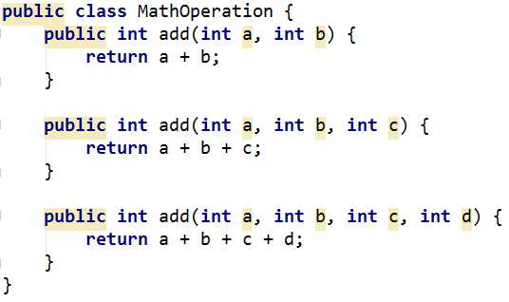

## Method Overriding

Read n lines from console. If line consist only one Double number it is square, if numbers are two it is rectangle. Numbers are sides of Rectangle. You need to have two classes:

* Rectangle
* Square

You should be able to use the class like this:

|  |
| --- |
| Main.java |
| **public static void** main(String[] args) **throws** IOException {  BufferedReader reader = **new** BufferedReader(**new** InputStreamReader(System.***in***));  **int** n = Integer.*parseInt*(reader.readLine());  List<Rectangle> listOfRectangles = **new** ArrayList<>();   **for** (**int** i = 0; i < n; i++) {  String[] reminder = reader.readLine().split( **" "**);  **if** (reminder.**length** == 1) {  listOfRectangles.add(**new** Square(Double.*parseDouble*(reminder[0])));  } **else** {  listOfRectangles.add(**new** Rectangle(Double.*parseDouble*(reminder[0]),  Double.*parseDouble*(reminder[1])));  }  }   **for** (Rectangle rectangle : listOfRectangles) {  System.***out***.println(rectangle.area());  } } |

### Examples

|  |  |
| --- | --- |
| **Input** | **Output** |
| 5  5  25 25  4 5  3 7  2 | 25.0  625.0  20.0  21.0  4.0 |

### Solution

Square class should look like this:

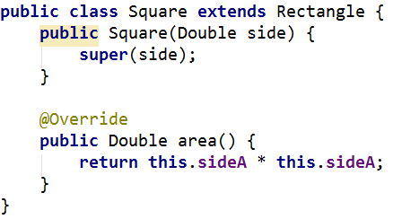

## Shapes

Create class hierarchy, starting with abstract class Shape:

* **Fields:**
  + **perimeter**
  + **area**
* **Encapsulation for this fields**
* **Abstract methods:**
  + calculatePerimeter()
  + calculateArea()

Extend Shape class with two children:

* **Rectangle**
* **Circle**

Each of them need to have:

* **Fields:** 
  + **height and width for Rectangle**
  + **radius for Circle**
* **Encapsulation for this fields**
* **Public constructor**
* **Concrete methods for calculations (perimeter and area)**